University of Delaware

Designing and Evaluating a Mini-Course on Time Management for Online Learners

Luyao Wei
EDUC 666: Action Research
November 6th, 2025

Abstract
This action research project explored the design, implementation, and assessment of a mini course titled "How to Manage Time Effectively", designed to improve learners' self-regulation and productivity in online learning environments. The goal was to help students identify effective time management strategies and reduce stress associated with poor planning and procrastination. The study also aimed to identify which course elements effectively supported learners' time management skills. Data was collected from participants through pre- and post-course surveys, including quantitative (Likert Scales) and qualitative (open-ended) questions. The findings suggest that concise, flexible, and interactive learning modules can effectively support the development of time management skills in online learners. The study also highlights the importance of reflective design practices and continuous assessment in creating meaningful digital learning experiences.

Table of Contents
Introduction 4
Literature Review 4
Methodology 6
Findings 8
Discussion 11
Conclusion 13
Reference 14

Introduction
Work-from-home and online learning are now widespread in the United States. In this online and blended learning environment, time management is one of the most critical skills impacting academic performance and learner satisfaction. “Despite the rapid development of blended learning in higher education, how to maintain students' retention and positive attitudes toward online learning has emerged as one key challenge” (Zhu, 2020). To address this issue, I developed a mini course called "How to Manage Time Effectively," designed to provide practical strategies for study planning, prioritization, and focus. The purpose of this action research project was to evaluate how learners engaged with and benefited from the mini course and to identify design improvements based on learner feedback and survey data.
The following research questions guide this study:
- What design elements of the mini course do learners find most helpful or engaging?
- What challenges or barriers do learners experience while completing the course?
- How can learner feedback be used to improve the structure, accessibility, and interactivity of the course?
These questions form the basis of an investigation into the effectiveness of the curriculum and the subsequent iterative design process. By exploring them, this research contributes to a deeper understanding of how digital instructional design supports the development and continuous improvement of practical skills.
Literature Review
Motivation
Many studies emphasize that learners’ time management directly affects academic performance. As Zeng (2025) states, “Individual academic motivation and time management are also important factors that influence online learning engagement and persistence”. Online learning or remote work often requires a high degree of self-discipline, but learners frequently struggle with procrastination, distraction, and scheduling difficulties.
“Self-determination theory makes a differentiation between autonomous and controlled motivation. Intrinsic, referring to spontaneous interest and enjoyment, and extrinsic motivation (behavior being instrumental in achieving an outcome) are regarded as two types of autonomous motivation” (Zhu, 2020). This mini course offers an opportunity to provide extrinsic motivation to learners who have weak self-motivation. The course plays a crucial role in supporting learners' metacognitive and self-regulation development.
Challenges
“Insofar as short-term memory corresponds to a production system’s working memory, it is reasonable to suppose that an increased number of statements in working memory increases cognitive load” (Sweller,1988). Although online learning offers many interactive learning opportunities, overly dense content or poorly structured modules can overwhelm or even distract learners. In this information-intensive era, how to teach knowledge to learners efficiently is a question I repeatedly consider when designing the mini-course. At the same time, I strive to meet the needs of learners of different ages who require less time to learn about technological operations.
Innovation
This mini course is a UDL-informed course design. “Universal Design sought to find elegant and effective ways to maximize the use of buildings and products by designing them from the outset as accessible for disabled users” (Lambert,2023). This course primarily uses the simplest text and dialogues to minimize learning barriers. Simultaneously, the course's visuals are minimalist, with clear layout and guidance, helping to maintain engagement and reduce the likelihood of distraction. The course uses a friendly tone to foster a learner-centered, more effective learning environment. All of these factors facilitated my collection and analysis of learner feedback and reflections.
Methodology
Research Design
This action research design uses a learning website to collect quantitative and qualitative data to gain a comprehensive understanding of how learners interact with and benefit from the course.
- Phases
- Planning: Develop a mini course on time management with one pre-survey and one post-survey.
- Action: Implement the course with volunteer participants.
- Observation: Gather data via pre- and post-surveys and reflections.
- Reflection: Analyze results and plan design improvements.
Participants
The study included eight participants from diverse backgrounds, all of whom were interested in improving their time management. The participants' basic information is as follows:
Students: 3 participants
Workers: 5 participants
Participation was voluntary, and no identity information was collected.
Setting
This study was conducted in a virtual environment, utilizing an online platform to distribute surveys and collect data. The study was conducted online through a published Articulate Rise 360 ​​course hosted on a public website (Netlify). Learners accessed the course asynchronously and completed all modules at their own pace.
Data Collection
Data was collected using a structured online survey developed through Google Forms. The mini course includes two surveys – one at the beginning of the lesson, and the other at the end of the lesson. The survey comprised several questions, including both Likert-scale and open-ended items, to capture quantitative and qualitative data.
- Pre-survey: Measured baseline knowledge, current habits, and self-confidence in managing time.
- Post-survey: Measured perceived learning gains, usability, and satisfaction.
- Open-ended question: Collect the biggest challenge to managing time. Collected qualitative insights about what learners found most/least helpful and design improvement suggestions.
Data Analysis
Quantitative data from Likert-scale responses were analyzed using descriptive statistics, including means and percentages. This method allows for a clear comparison of how hard learners manage time. It also provides a clear understanding of learners' satisfaction with various aspects of the mini-course.
Qualitative data from open-ended responses were analyzed thematically, such as engagement, usability, and applicability. Qualitative data also provided specific information for revising the course content and interactive design.
Ethical Consideration
- Participation was voluntary, with informed consent obtained.
- Data was collected anonymously, and no personal identifiers were recorded.
- Learners could withdraw from the study at any time without penalty.
Action Plan
- Cycle 1: Develop the mini-course and two surveys.
- Cycle 2: Publish the mini-course and gather feedback.
- Cycle 3: Analyze data and feedback, and identify improvement areas (e.g., wording, picture usage, increase interactivity, and adjust pacing).
- Cycle 4: Implement refinements and prepare for a second iteration of learner testing.
Resources and Materials
- Software: Articulate Rise 360 (for course creation); Google Forms (for surveys).
- Hardware: Personal computer and standard internet browser access.
- Design references: UDL Guidelines, ADDIE Framework
Findings
Overview of Data Collected
This section presents the results of the quantitative and qualitative data collection conducted after participants completed the mini-course. The eight learners complete the pre-survey in the first lesson and the post-survey in the fourth lesson. The findings integrate both quantitative Likert-scale data and qualitative open-ended responses. The findings are organized to align with the research questions, supported by tables, charts, and sample responses for clarity.
Quantitative Results
Confidence in Managing Time. One of the questions that appeared in both surveys is about their confidence in managing work/study time. After taking the time-management mini-lesson, the average score increases. Participants were asked to rate their confidence on a Likert scale (1 = Strongly Disagree; 5 = Strongly Agree).
Table 1: The average confidence in managing time in 2 surveys
Surveys | Average Confidence
Pre-survey | 3.375
Post-survey | 4.625

Figure 1: The rating in both the pre- and the post-survey
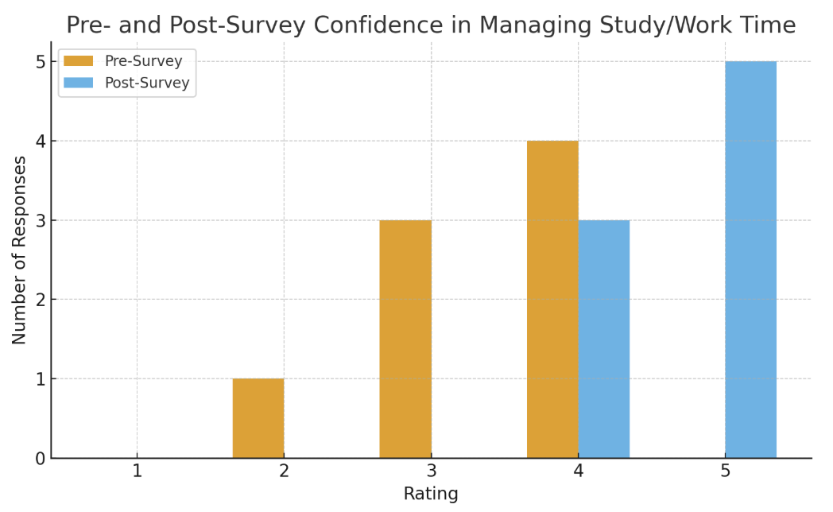
These charts show that learners have a high level of self-efficacy after being exposed to the teaching materials.
Ease of Navigation and Accessibility. Participants generally found the course easy to navigate and presented in a format that aligned with their preferences. Seven learners (87.5%) strongly agreed, and one (12.5%) agreed. These results highlight the success of UDL-inspired design choices that offer multiple representations and a simple interactive flow.
Figure 2: The rating of ease of navigation and accessibility
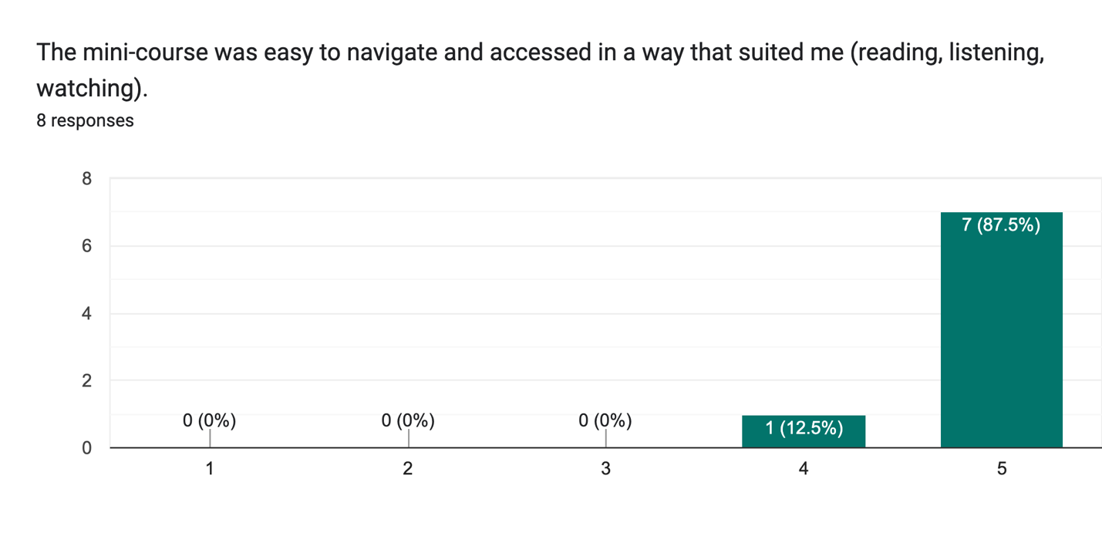
Qualitative Results
Helpful and Engaging Elements. Findings relevant to my research question indicate that some learners find interactive tools and visual charts to be engaging parts of mini-lessons, and these tools enhance their understanding.
Sample Responses:
- “Time & Habit Tracking Tool. Using tools can directly help me concentrate from the outside and remind me.”
- “The dialogue interactions and the photos of digital tools that can help for time management.”
- “The digital tools are more helpful, because it's easier to organize simple tasks on devices.”
Challenges or Barriers During the Lesson. Regarding another research question, the results showed that learners' main challenge was still having a lot of things to do, even with many helpful tools. Some also felt that phone notifications still interfered with their study/work time.
Sample Responses:
- “Using tools does not force me to complete the tasks that must be done.”
- “I feel writing or using tech to manage my time still needs my time.”
- “Notifications from my phone.”
These issues effectively reflect learners' struggles and provided me with more ideas and inspiration for thinking and improving this mini-course.
Discussion
This action research aims to examine learners’ perceptions of the online time management mini-course for self-study progress and to identify targeted improvements to enhance their design and accessibility.
Research Question 1: What design elements of the mini course do learners find most helpful or engaging?
Participants agreed that the concise activities, step-by-step breakdowns, and multimedia elements, such as visuals, examples, and interactive prompts, were particularly engaging parts of the course. This supports Mayer's (2021) principles of multimedia learning, emphasizing the use of a mix of text and images, and the benefits of combining concise text with visuals to reduce unnecessary cognitive load.
Overall, the website design and multimedia elements chosen for this mini-course were sufficient to keep learners engaged. Furthermore, learner feedback underscores the importance of using a UDL framework for designing online courses.
Research Question 2: What challenges or barriers do learners experience while completing the course?
Despite overall positive engagement, participants reported some difficulties, particularly distractions from browsing certain pages or receiving notifications on their digital devices. These findings reflect widespread problems observed in self-directed online learning environments.
Hays and Kustes (2024) indicate that online education permits far more sources of interruption, including phone calls, error messages, text-message alerts, dropped connections, social media notifications, and more. These are common problems encountered by many in online learning environments. Enriching online course content improves learner engagement and increases the time spent on learning pages are the directions we should focus on when we are designing an online course.
Research Question 3: How can learner feedback be used to improve the structure, accessibility, and interactivity of the course?
Learner feedback provided clear guidance for improvement. Participants expressed interest in diverse interactions, particularly the dialog box sections, which increased learners’ engagement. Participants indicated that more diverse interactions could be added to the mini-course. This suggestion is supported by research showing that varied activity types, such as branching scenarios and drag-and-drop interactions, enhance learner motivation and deepen knowledge transfer (Fiock, 2020).
Taken together, these suggestions and ideas reinforce the value of iterative instructional design and the role of learner voices in improving digital learning environments. This action study demonstrates that combining learner feedback with research-based principles enables designers to optimize course structure, accessibility, and engagement, ultimately improving learning outcomes.
Conclusion
This action research project examined the effectiveness of a self-paced time management mini-course and explored how learner feedback guided iterative improvement. The results showed that the course successfully supported learners' understanding of time management strategies, and participants demonstrated confidence in applying the technologies showcased. Learners appreciated the course's clear structure, visual support, and practical examples, all aligned with cognitive load reduction and student-centered digital design principles.
Indeed, the results also revealed specific areas for improvement. Participants pointed to challenges in navigation clarity, how to revisit previous learning content, and the need for greater interactivity and personalization. These insights led to a series of revisions that will shape the next phase of the course, ensuring it is more accessible, engaging, and caters to diverse learner needs.
Overall, this research underscores the importance of continuous evaluation and iterative refinement in instructional design practice. By basing design decisions on learner feedback and academic research, educators and designers can create more effective digital learning experiences. The findings emphasize that well-designed online learning modules can positively impact learners' confidence and motivation.

Reference
Zhu, Y., Zhang, J. H., Au, W., & Yates, G. (2020). University students’ online learning attitudes and continuous intention to undertake online courses: a self-regulated learning perspective. Educational Technology Research and Development, 68(3). https://doi.org/10.1007/s11423-020-09753-w

Zeng, H., & Xin, Y. (2025). Comparing learning persistence and engagement in asynchronous and synchronous online learning, the role of autonomous academic motivation and time management. Interactive Learning Environments, 33(1). https://doi.org/10.1080/10494820.2024.2344033

Sweller, J. (1988). Cognitive load during problem solving: Effects on learning. Cognitive Science, 12(2).

Lambert, R., McNiff, A., Schuck, R., Imm, K., & Zimmerman, S. (2023). “UDL is a way of thinking”; theorizing UDL teacher knowledge, beliefs, and practices. Frontiers in Education (Lausanne), 8. https://doi.org/10.3389/feduc.2023.1145293

Mayer, R. E. (2021). Multimedia learning (3rd ed.). Cambridge University Press.

Hays, M. J., Kustes, S. R., & Bjork, E. L. (2024). Metacognitive Management of Attention in Online Learning. Journal of Intelligence, 12(4), Article 46. https://doi.org/10.3390/jintelligence12040046

Fiock, H. (2020). Designing a community of inquiry in online courses: Supportive strategies. Online Learning, 24(3).

